Name: Robert Loth Class: COMSC 200-1369 Lab: 1 Due Date: 2/11/19

Problem-1

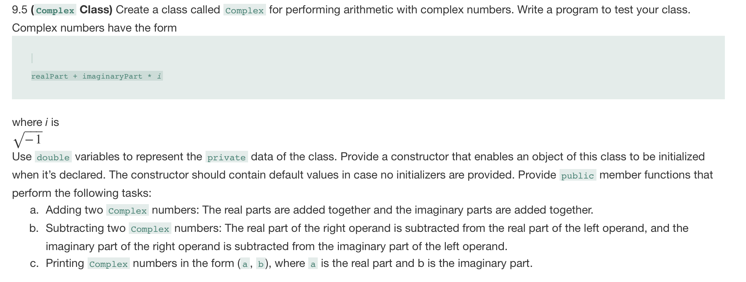
ANSWER:
Complex.h:
#ifndef COMPLEX_H
#define COMPLEX_H

#include <iostream> //cout
#include <string> //string literals in PrintComplexNumber

class Complex
{
public:
Complex();
Complex(double real, double imaginary);
~Complex();
Complex operator+ (Complex c2); //performs c1 + c2
Complex operator- (Complex c2); //performs c1 - c2
void PrintComplexNumber(); //in form (a, b) //no endline
private:
double realPart;
double imaginaryPart;
};

#endif
Complex.cpp:
#include "Complex.h"

Complex::Complex()
{
realPart = 0.0;
imaginaryPart = 0.0;
}

Complex::Complex(double real, double imaginary)
{
realPart = real;
imaginaryPart = imaginary;
}

Complex::~Complex()
{
}

Complex Complex::operator+(Complex c2)
{
Complex temp;
temp.realPart = this->realPart + c2.realPart;
temp.imaginaryPart = this->imaginaryPart + c2.imaginaryPart;
return temp;
}

Complex Complex::operator-(Complex c2)
{
Complex temp;
temp.realPart = this->realPart - c2.realPart;
temp.imaginaryPart = this->imaginaryPart - c2.imaginaryPart;
return temp;
}

void Complex::PrintComplexNumber()
{
std::cout << "(" << this->realPart << ", " << this->imaginaryPart << ")";
}

main.cpp:
#include <iostream>
#include "Complex.h"
using namespace std;
int main()
{
//initialize
Complex TestComp;
Complex Comp2(8, -9);
Complex Comp3(-4, 6);

//print all
TestComp.PrintComplexNumber();
cout << endl;
Comp2.PrintComplexNumber();
cout << endl;
Comp3.PrintComplexNumber();
cout << endl;

//test operator+
TestComp = Comp2 + Comp3;
TestComp.PrintComplexNumber(); //should be (4, -3)
cout << endl;

//test operator-
TestComp = Comp2 - Comp3; //should be 12, -15
TestComp.PrintComplexNumber();
cout << endl;

system("pause");
return 0;
}

SCREEN SHOT OF THE SAMPLE RESULTS.
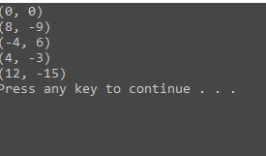

Problem-2
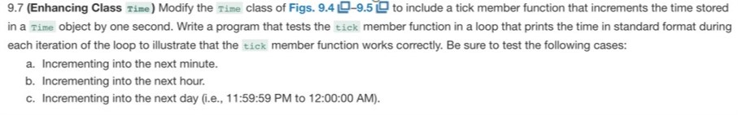

ANSWER:
Time.h:
#ifndef TIME
#define TIME
#include <string>
using namespace std;
class Time
{
public:
//set
void setTime(int, int, int);
void setHour(int);
void setMinute(int);
void setSecond(int);
void tick(); //increment a time object by one second

//get
unsigned int getHour() const;
unsigned int getMinute() const;
unsigned int getSecond() const;
string toUniversalString() const;
string toStandardString() const;
private:
unsigned int hour{ 0 };
unsigned int minute{ 0 };
unsigned int second{ 0 };
};
#endif

Time.cpp:
#include <iomanip>
#include <stdexcept>
#include <sstream>
#include <string>
#include "Time.h"

using namespace std;

void Time::setTime(int h, int m, int s)
{
setHour(h);
setMinute(m);
setSecond(s);
}
void Time::setHour(int h)
{
if (h >= 0 && h < 24)
{
hour = h;
}
else {
throw invalid_argument("hour must be 0-23");
}
}
void Time::setMinute(int m)
{
if (m >= 0 && m < 60)
{
minute = m;
}
else
{
throw invalid_argument("minute must be 0-59");
}
}
void Time::setSecond(int s)
{
if (s >= 0 && s < 60)
{
second = s;
}
else
{
throw invalid_argument("second must be 0-59");
}
}
void Time::tick()
{
++second;
if (second == 60) {
++minute;
second = 0;
}
if (minute == 60)
{
++hour;
minute = 0;
}
if (hour == 24)
{
hour = 0;
minute = 0;
second = 0;
}

}

unsigned int Time::getHour() const {return hour;}
unsigned int Time::getMinute() const {return minute;}
unsigned int Time::getSecond() const { return second; }

string Time::toUniversalString() const
{
ostringstream output;
output << setfill('0') << setw(2) << getHour() << ":"
<< setw(2) << getMinute() << ":" << setw(2) << getSecond();
return output.str();
}

string Time::toStandardString() const
{
ostringstream output;
output << ((getHour() == 0 || getHour() == 12) ? 12 : getHour() % 12)
<< ":" << setfill('0') << setw(2) << getMinute() << ":" << setw(2)
<< getSecond() << (hour < 12 ? " AM" : " PM");
return output.str();
}

Main.cpp:
#include <iostream>

#include "Time.h"
using namespace std;

int main()
{
Time testObj;
testObj.setTime(23, 59, 59);
for (int i = 0; i < 61; i++)
{
cout << testObj.toStandardString() << endl;
testObj.tick();
}
cout << testObj.toStandardString() << endl;
system("pause");
return 0;
}

SCREEN SHOT OF THE SAMPLE RESULTS.
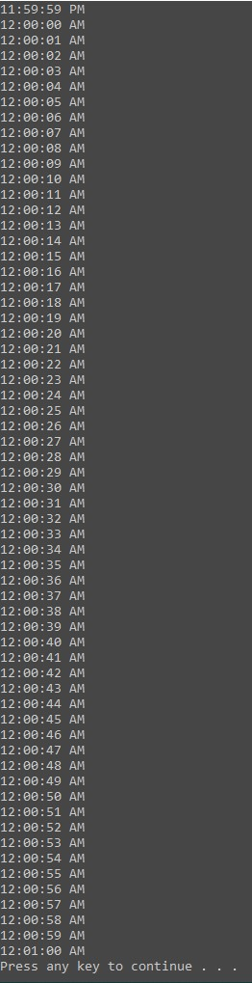
Problem-3
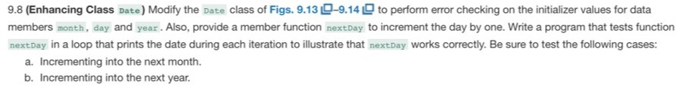
Date.h
#ifndef DATE
#define DATE

#include <array>
#include <iostream>

class Date
{
friend std::ostream& operator<<(std::ostream&, const Date&);
public:
Date(int m = 1, int d = 1, int y = 1900);
void setDate(int, int, int);
Date& operator++();
Date operator++(int);
Date& operator+=(unsigned int);
static bool leapYear(int);
bool endOfMonth(int) const;

private:
unsigned int month;
unsigned int day;
unsigned int year;

static const std::array<unsigned int, 13> days;
void nextDay();

};
#endif

Date.cpp
#include <iostream>
#include <string>

#include "Date.h"
using namespace std;

const array<unsigned int, 13> Date::days {
0, 31, 28, 31, 30, 31, 30, 31, 31, 30, 31, 30, 31 };

Date::Date(int month, int day, int year) {
setDate(month, day, year);
}

void Date::setDate(int mm, int dd, int yy) {
if (mm >= 1 && mm <= 12) {
month = mm;
}
else throw invalid_argument{ "Month must be 1-12" };

if (yy >= 1900 && yy <= 2100) {
year = yy;
}
else throw invalid_argument{ "year must be 1900-2100" };

if ((mm == 2 && leapYear(year) && dd >= 1 && dd <= 29) ||
(dd >= 1 && dd <= days[mm])) {
day = dd;
}
else throw invalid_argument{ "Day is out of range for current month and year" };

}

Date& Date::operator++() {
nextDay();
return *this;
}

Date Date::operator++(int) {
Date temp{ *this };
nextDay();
return temp;
}

Date& Date::operator+=(unsigned int additionalDays) {
for (unsigned int i = 0; i < additionalDays; ++i) {
nextDay();
}
return *this;
}

bool Date::leapYear(int testYear) {
return (testYear % 400 == 0 || (testYear % 100 != 0 && testYear % 4 == 0));
}

bool Date::endOfMonth(int testDay) const {
if (month == 2 && leapYear(year)) {
return testDay == 29;
}
else return testDay == days[month];
}

void Date::nextDay() {
if (!endOfMonth(day)) {
++day;
}
else {
if (month < 12) {
++month;
day = 1;
}
else {
++year;
month = 1;
day = 1;
}
}
}

ostream& operator<<(ostream& output, const Date& d) {
static string monthName[13]{ "",
"January",
"February",
"March",
"April",
"May",
"June",
"July",
"August",
"September",
"October",
"November",
"December" };
output << monthName[d.month] << ' ' << d.day << ", " << d.year;
return output;
}

Main.cpp:
#include <iostream>

#include "Date.h"
using namespace std;
int main() {

Date testDate(11, 29, 1999);
for (int i = 0; i < 34; ++i) {
cout << testDate++ << endl;
}
system("pause");
return 0;
}

Screenshot:
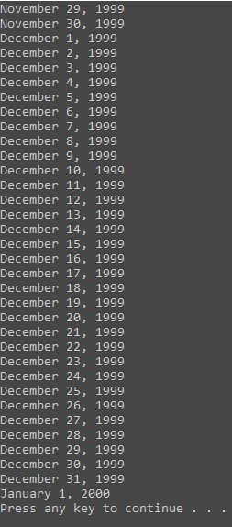

Problem-4
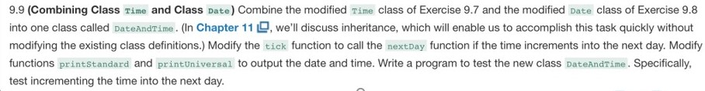
DateAndTime.h:
#pragma once

#include <iomanip>
#include <sstream>

#include "Date.h"
#include "Time.h"
class DateAndTime : public Date, public Time
{
friend std::ostream& operator<<(std::ostream&, const Date&);
public:
DateAndTime(int mm, int dd, int yyyy, int hour, int minute, int second);
DateAndTime& tick(); //overloaded from Time class
string printUniversal() const;
string printStandard() const;
};

DateAndTime.cpp:

#include "DateAndTime.h"

using namespace std;

DateAndTime::DateAndTime(int mm, int dd, int yyyy, int hour, int minute, int second)
{
setDate(mm, dd, yyyy);
setTime(hour, minute, second);
}

DateAndTime& DateAndTime::tick()
{
Time::tick();
if (getSecond() == 0 && getMinute() == 0 && getHour() == 0) {
Date::operator++();
}
return *this;
}

string DateAndTime::printUniversal() const {
ostringstream output;
output << *this << " " << Time::toUniversalString();
return output.str();
}

string DateAndTime::printStandard() const {
ostringstream output;
output << *this << " " << Time::toStandardString();
return output.str();
}

Main.cpp:
#include <iostream>

#include "DateAndTime.h"
using namespace std;
int main() {

DateAndTime testDT(2, 11, 2019, 23, 59, 45);
for (int i = 0; i < 16; ++i) {
testDT.tick();
cout << testDT.printStandard() << endl;

}
system("pause");
return 0;
}
Screenshot:
